Content

1 Add views to node 1

1.1 Integrating html 1

1.2 link views to controller 5

2 Pass data from controller to the views 6

3 Pass form data to login and signup 7

3.1 signup 7

3.2 login 10

4 add auth middleware to all routes except login page 12

5 login use cookie 13

6 fileupload 14

# 1 Add views to node

Static html repo: <https://github.com/onebit256/static-html>

Node without-views: <https://github.com/onebit256/batch2-lab4-node-without-views>

Tasks:

1. Turn this static html into nodejs template
2. Add the views to the nodejs app and turn this nodejs api application to a normal nodejs application with views

## 1.1 Integrating html

1. Create a public folder in the project older. And move css js to that public folder,
2. Create a vewis folder and change html to ejs and move them to the views folder
3. Npm i ejs

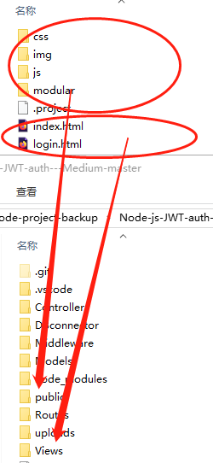

3 split html into parts

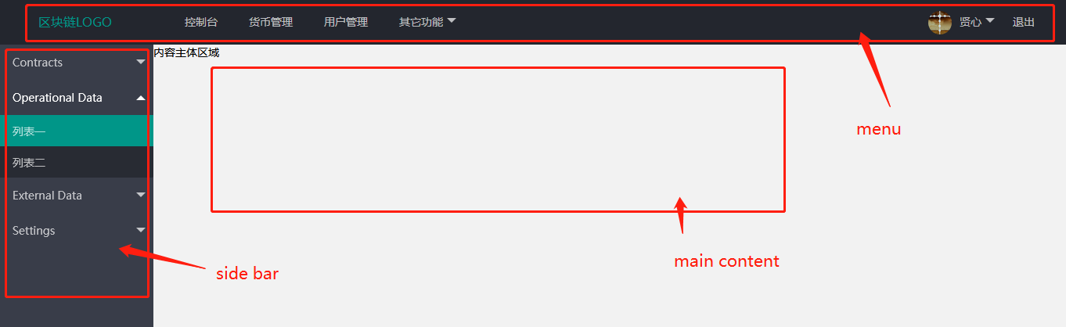

How to split?

1 always write header and footer

2 in this case, we can create a component for the sidebar, create a component for the menu, and a component for the main content, if necessary.

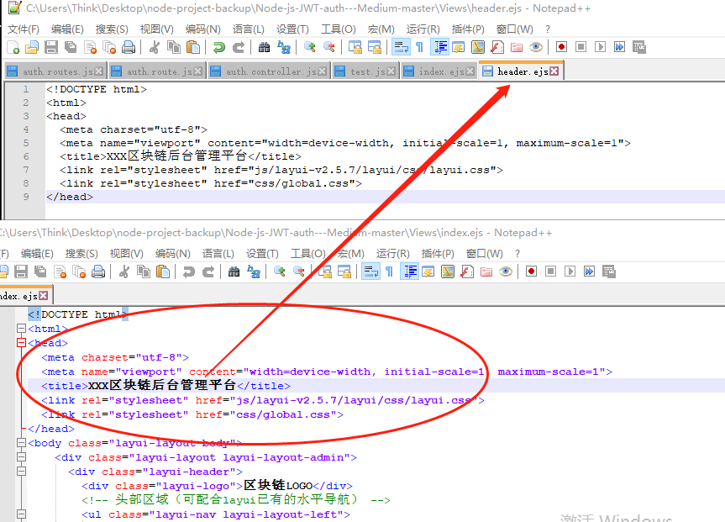

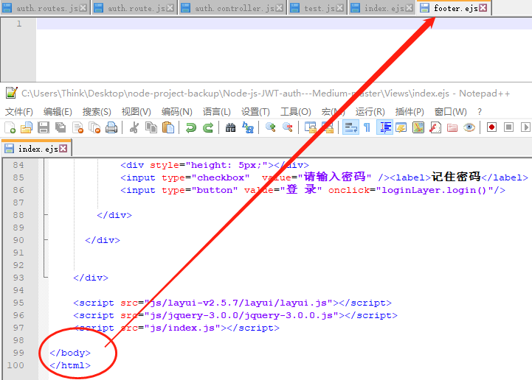

Eventually:

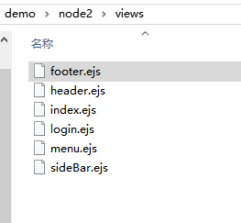

Index.ejs

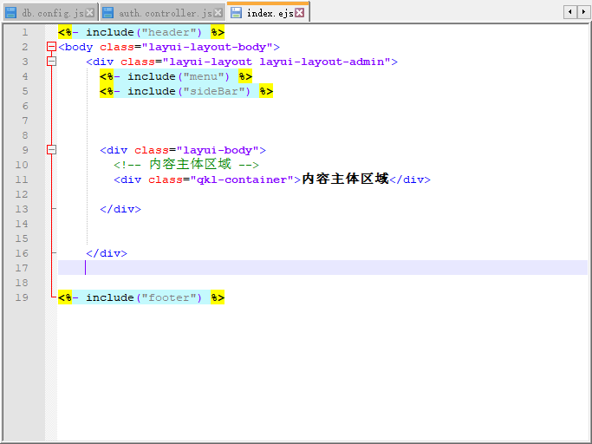

4 link the template to nodejs program: add the following 3 lines to app.js

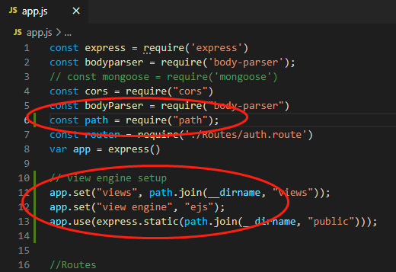

## 1.2 link views to controller

What we want to do in this section is add a set of views, routes and controllers, and allow users to do registration via the views instead of api requests

1. Define routes

Create a file called dashboard.route.js

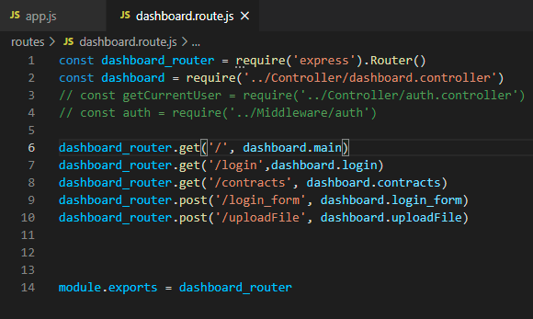

1. Add this route to app use

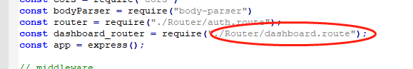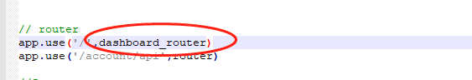

1. Add controller

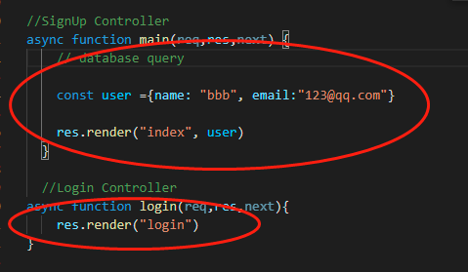

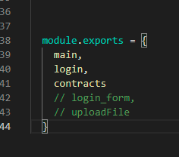

Verify if the views connected. Run debug, you will be able to see:

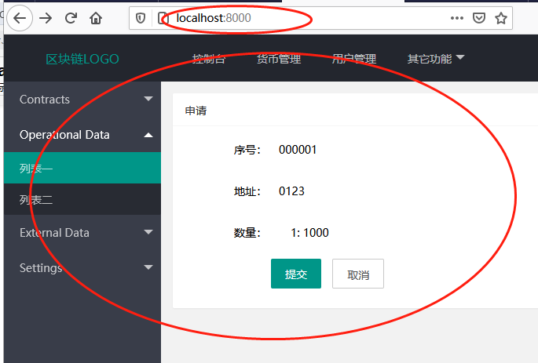

# 2 Pass data from controller to the views

* 1. defines the data in controller

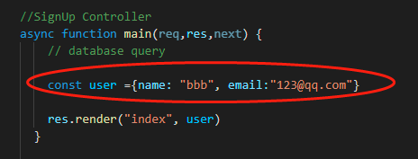

Res.render sends the data to the ejs views

* 1. sets parameters in views

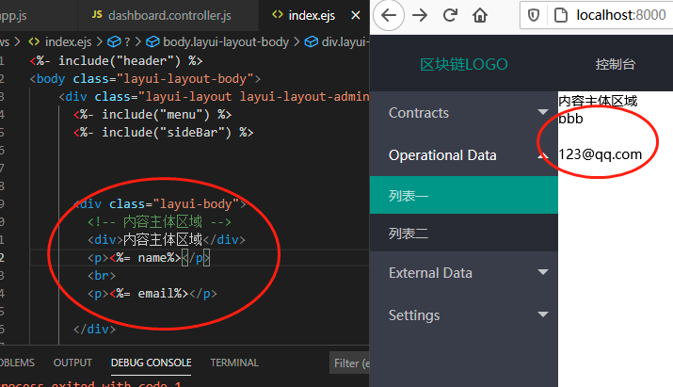

2.3 open the browser, you will see the data passed down to the view

# 3 Pass form data to login and signup

In this section, we need to write a set of model, view, and controller for login and signup

## 3.1 signup

1 create a signup route to handle the form data, and create its corresponding controller

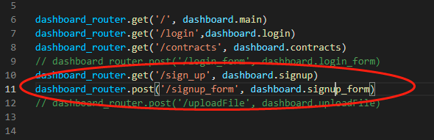

2 add controller

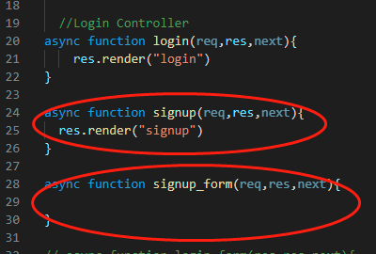

add controller for the sign_up and for the signup form

3 create view for sign up

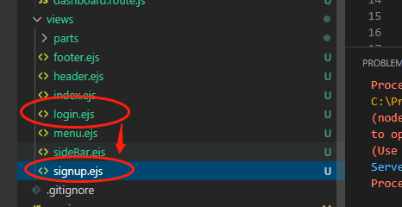

Copy login.ejs directly and change the name to signup.ejs

3 Create form in the view

Change the view from

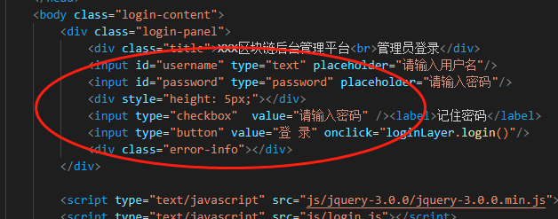

to

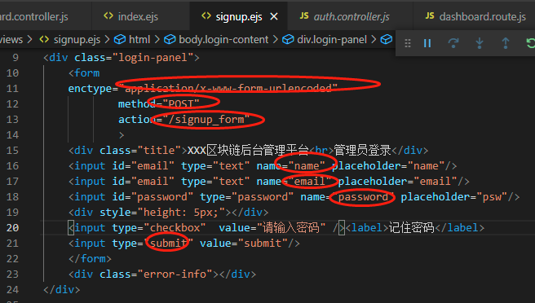

Notes:

- Set form data to www-form-urlencode

- Assign the route path to the action and change the name to “/signup_form”

- Set the variable names

- Set the submit button type to be “submit”

4 copy the sign up logic from the auth.controller.js to signup_form controller

Why? Because auth controller logic is for api. We need to write a set of mvc, and their logic is the same, so we could copy the code directly

The only thing we need to change is

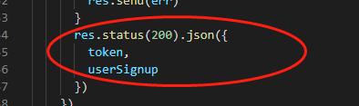

To

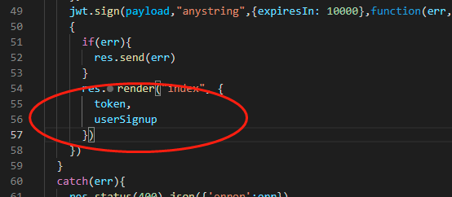

5 add the username to the index

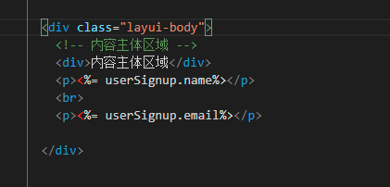

6 Test

Run the application, after type into the name email and psw

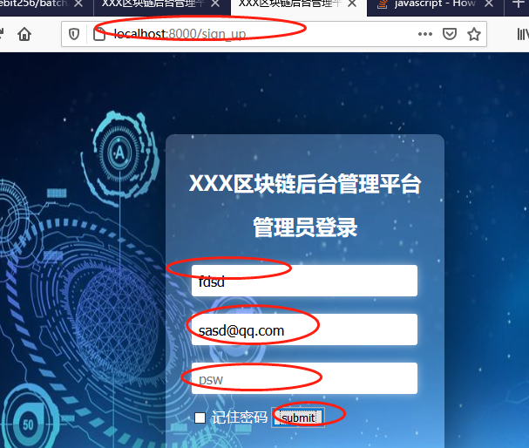

You will be able to see

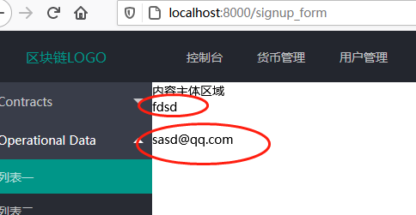

## 3.2 login

1 add router

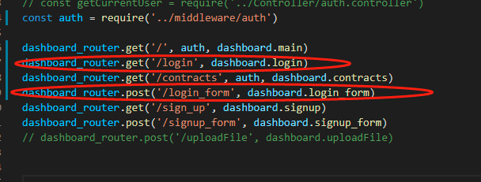

2 add controller and copy the login logic from api’s controller

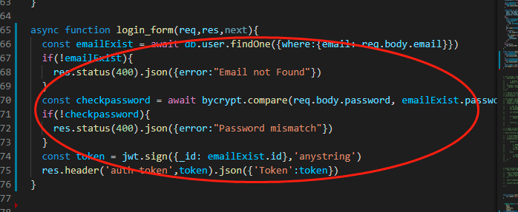

3 add view

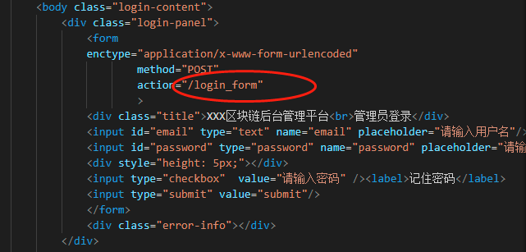

4 verify

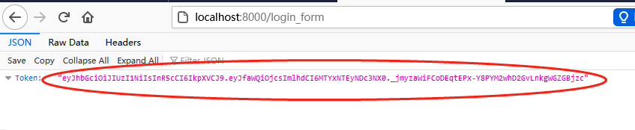

5 change json return to page render

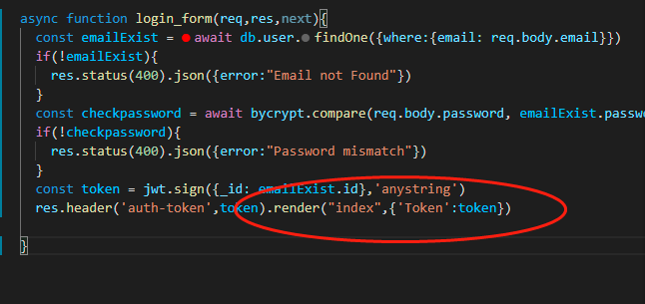

Why render? Not redirect

# 4 add auth middleware to all routes except login page

1. Create a folder called middleware and copy the middleware from the project 2

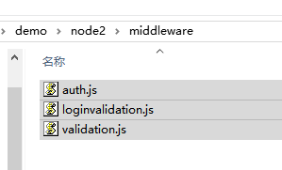

1. Add middleware

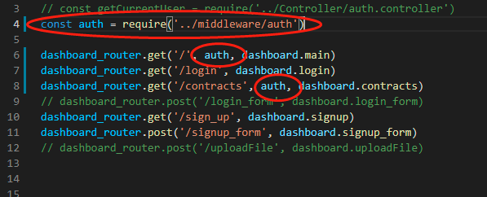

1. Redirect unauthorized user to login page: change auth.js from api redirect to page redirect

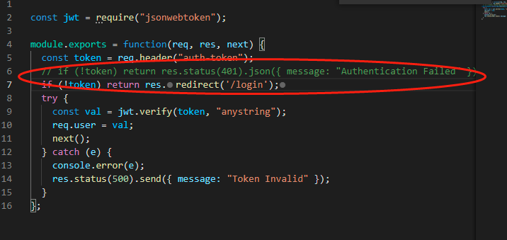

1. Verify open 127.0.0.1:8000, will be redirected to 127.0.0.1:8000/login

# 5 login use cookie

Npm i cookie-parser

1. Add cookie

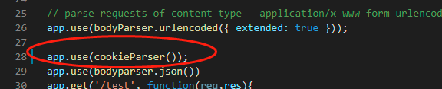

2 use cookie to store token

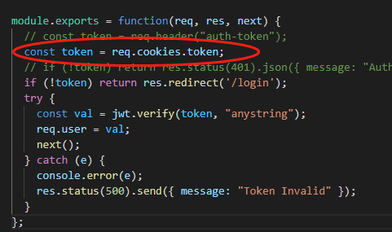

3 add cookie to the controller

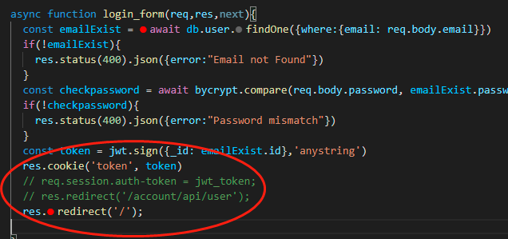

4 verify

After the first login, you don’t need to psw to login, cookie will keep your JWT

# 6 fileupload